

Tribhuwan University

Institute of Engineering

Purbanchal Campus, Dharan

C Lab Report

Submitted By:

Name: Tilak Thapa

Roll No: PUR079BCT094

Submitted To:

Department of Electronic and Computer Engineering

Lab Date:

Submission Date:

Signature:

**Table of Contents**

1. Lab Sheet 1 [ To be familiar with C Programming] ……………………………………………
2. Lab Sheet 2 [To be familiar Data types, Constants, Operators and Expressions] ……………..
3. Lab Sheet 3 [To be familiar with selective structure (branching)] ………………………….......
4. Lab Sheet 4 [To be familiar with Unformatted and Formatted I/0] ……………………………
5. Lab Sheet 5 [To be familiar with LOOPS] ………………………………………………………
6. Lab Sheet 6 [To be familiar with FUNCTIONS:] ……………………………………………….
7. Lab Sheet 7 [To be familiar with Array] ………………………………………………………...
8. Lab Sheet 8 [To be familiar with Pointers] ………………………………………………………
9. Lab Sheet 9 [To be familiar with Structure] ……………………………………………………..
10. Lab Sheet 10 [To be familiar with String] ………………………………………………………..
11. Lab Sheet 11 [To be familiar with File Handling] ……………………………………………….

**Lab Sheet 1**

1. WAP to display hello world.

* **Objective**

The objective of this program is to write a code that displays the message "Hello, World!" on the console.

* **Algorithm**

1. Start
2. Display "Hello, World!"
3. Stop

* **Flowchart**

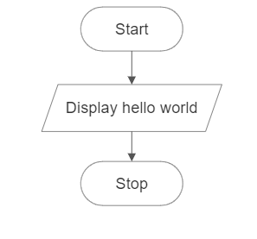

* **Code**

#include <stdio.h>

int main( ) {

printf("Hello, World!\n");

return 0;

}

* **Output**

Hello, World!

* **Discussion and Conclusion**

This program displays the message "Hello, World!" on the console. The printf function is used to print the message. The \n is used to add a new line after the message. The program was implemented using the VS Code IDE and compiled using gcc to generate an executable file.

1. WAP to display your name, roll number and address

* **Objective**

The objective of this program is to write a code that displays your name, roll number, and address on the console.

* **Algorithm**

1. Start
2. Display name, roll number and address
3. Stop

* **Flowchart**

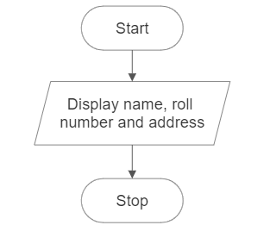

* **Code**

#include <stdio.h>

int main( )

{

    printf("Name: Tilak Thapa\n");

    printf("Roll Number: PUR079BCT094\n");

    printf("Address: Tulsipur - 4, Dang\n");

    return 0;

}

* **Output**

Name: Tilak Thapa

Roll Number: PUR079BCT094

Address: Tulsipur - 4, Dang

* **Discussion and Conclusion**

This program displays my name, roll number, and address on the console. The printf function is used to print each piece of information. The newline character \n is used to add a new line after each line of output. The program was implemented using the VS Code IDE and compiled using gcc to generate an executable file.

1. WAP to add two integer variables and print sum

* **Objective**

The objective of this program is to write a code that adds two predefined integer variables and prints their sum.

* **Algorithm**

1. Start.
2. Declare two integer variables, num1 and num2, and initialize them with predefined values.
3. Calculate the sum of num1 and num2 and store it in a variable called sum.
4. Print the value of sum.
5. Stop.

* **Flowchart**

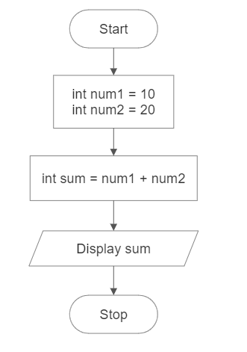

* **Code**

#include <stdio.h>

int main( )

{

int num1 = 10;

int num2 = 20;

int sum = num1 + num2;

printf("Sum: %d\n", sum);

return 0;

}

* **Output**

Sum: 30

* **Discussion and Conclusion**

This program adds two predefined integer variables, num1 and num2, and prints their sum. The values of num1 and num2 are initialized with the numbers 10 and 20, respectively. The sum of num1 and num2 is calculated and stored in the sum variable using the addition operator (+). The printf function is used to display the value of sum. The program was implemented using the VS Code IDE and compiled using gcc to generate an executable file. The objective of the program was achieved, and the code executed successfully.

1. WAP to multiply two integer variables and print product

* **Objective**

The objective of this program is to write a code that multiplies two integer variables and prints their product.

* **Algorithm**

1. Start.
2. Declare two integer variables, num1 and num2, and initialize them with predefined values.
3. Calculate the product of num1 and num2 and store it in a variable called product.
4. Print the value of product.
5. Stop.

* **Flowchart**

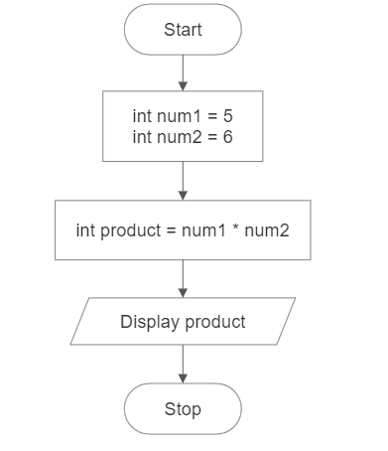

* **Code**

#include <stdio.h>

int main()

{

int num1 = 5;

int num2 = 6;

int product = num1 * num2;

printf("Product: %d\n", product);

return 0;

}

* **Output**

Product: 30

* **Discussion and Conclusion**

This program multiplies two integer variables, num1 and num2, and prints their product. The values of num1 and num2 are assigned as 5 and 6, respectively. The product of num1 and num2 is calculated and stored in the product variable using the multiplication operator (*). The printf function is used to display the value of product. The program was implemented using the VS Code IDE and compiled using gcc to generate an executable file. The objective of the program was achieved, and the code executed successfully.

1. WAP to calculate and display the simple interest.

* **Objective**

The objective of this program is to write a code that calculates and displays the simple interest based on predefined values for principal amount, rate, and time.

* **Algorithm**

1. Start.
2. Declare and initialize three variables: principal, rate, and time with predefined values.
3. Calculate the simple interest using the formula: interest = (principal * rate * time) / 100 and assign the value to variable called interest.
4. Print the value of the interest.
5. Stop.

* **Flowchart**

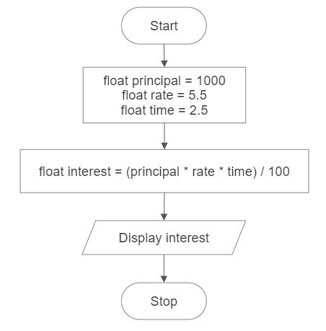

* **Code**

#include <stdio.h>

int main()

{

float principal = 1000;

float rate = 5.5;

float time = 2.5;

float interest = (principal * rate * time) / 100;

printf("Simple Interest: Rs %f\n", interest);

return 0;

}

* **Output**

Interest: Rs 137.500000

* **Discussion and Conclusion**

This program calculates and displays the simple interest based on predefined values for the principal amount, rate of interest, and time period. The values of principal, rate, and time are initialized as 1000, 5.5, and 2.5, respectively. The simple interest is calculated using the formula: interest = (principal * rate * time) / 100. The calculated interest value is then printed using the printf function. The program was implemented using the VS Code IDE and compiled using gcc to generate an executable file.

1. WAP to calculate the area of the circle

* **Objective**

The objective of this program is to write a code that calculates the area of a circle based on a predefined radius.

* **Algorithm**

1. Start.
2. Declare a constant variable for PI and a variable for the radius and assign their values.
3. Calculate the area of the circle using the formula: area = pi * radius * radius and assign the value to a variable called area.
4. Print the value of the area.
5. Stop.

* **Flowchart**

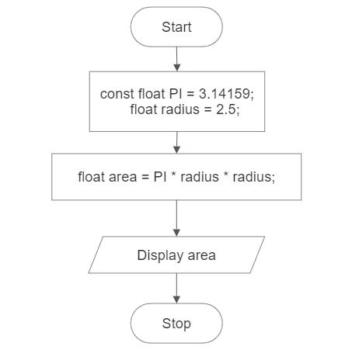

* **Code**

#include <stdio.h>

int main( )

{

const float PI = 3.14159;

float radius = 2.5;

float area = PI * radius * radius;

printf("Area of the circle: %.2f sq unit.\n", area);

return 0;

}

* **Output**

Area of the circle: 19.63 sq unit.

* **Discussion and Conclusion:**

This program calculates the area of a circle based on a predefined radius. The value of radius is assigned as 2.5. The area of the circle is calculated using the formula: area = PI * radius * radius, where PI is a constant value representing the mathematical constant pi (approximately 3.14159). The calculated area value is then printed using the printf function. The program was implemented using the VS Code IDE and compiled using gcc to generate an executable file

**Lab Sheet 2**

1. WAP to declare integer, float and character variable. Initialize them with certain value and print those values. Also display the size of variables.

* **Objective**

The objective of this program is to write a code that declares integer, float, and character variables, initializes them with certain values, and prints the values. Additionally, the program will display the size of each variable.

* **Algorithm**

1. Start.
2. Declare an integer variable and assign certain value.
3. Declare a float variable and assign certain value.
4. Declare a character variable and assign certain value.
5. Print the values of the variables using the printf function.
6. Use the sizeof() operator to determine the size of each variable and print the sizes of the variables.
7. Stop.

* **Flowchart**

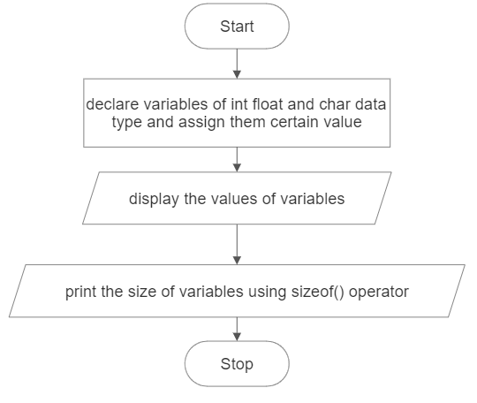

* **Code**

#include <stdio.h>

int main( )

{

int integerVariable = 10;

float floatVariable = 3.14;

char charVariable = 'A';

printf("Integer Variable: %d\n", integerVariable);

printf("Float Variable: %f\n", floatVariable);

printf("Character Variable: %c\n\n", charVariable);

printf("Size of Integer Variable: %d bytes\n", sizeof(integerVariable));

printf("Size of Float Variable: %d bytes\n", sizeof(floatVariable));

printf("Size of Character Variable: %d bytes\n", sizeof(charVariable));

return 0;

}

* **Output**

Integer Variable: 10

Float Variable: 3.140000

Character Variable: A

Size of Integer Variable: 4 bytes

Size of Float Variable: 4 bytes

Size of Character Variable: 1 bytes

* **Discussion and Conclusion**

This program declares an integer variable, a float variable, and a character variable. The variables are initialized with certain values. The values of the variables are printed using the printf function. The sizeof operator is used to determine the size of each variable, and the sizes are printed. The program was implemented using the VS Code IDE and compiled using gcc to generate an executable file.

1. WAP to swap the values of the variable with and without using third variable.

* **Objective**

The objective of this program is to write a code that swaps the values of two variables, both with and without using a third variable.

1. **Approach 1 (Using third variable)**

* **Algorithm**

1. Start.
2. Declare two variables: num1 and num2 and initialize them with certain values.
3. Declare a third variable, temp.
4. Display the value of num1 and num2 before swapping.
5. Assign the value of num1 to temp.
6. Assign the value of num2 to num1.
7. Assign the value of temp to num2.
8. Print the swapped values of num1 and num2.
9. Stop.

* **Flowchart**

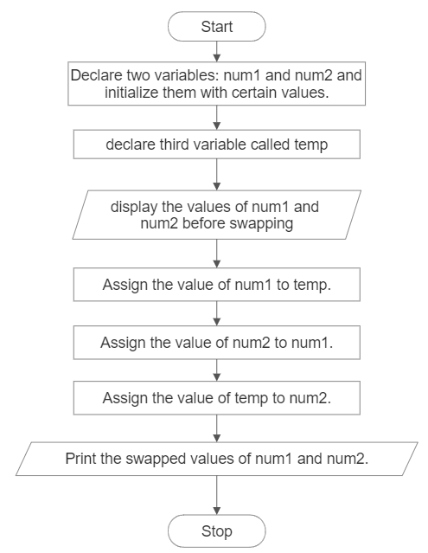

* **Code**

#include <stdio.h>

int main( )

{

int num1 = 10;

int num2 = 20;

int temp;

printf("Before swapping:\n");

printf("num1 = %d\n", num1);

printf("num2 = %d\n", num2);

temp = num1;

num1 = num2;

num2 = temp;

printf("After swapping (using third variable):\n");

printf("num1 = %d\n", num1);

printf("num2 = %d\n", num2);

return 0;

}

* **Output**

Before swapping:

num1 = 10

num2 = 20

After swapping (using third variable):

num1 = 20

num2 = 10

1. **Approach 2 (Without Using Third Variable)**

* **Algorithm**

1. Start.
2. Declare two variables: num1 and num2 and initialize them with certain values.
3. Display the value of num1 and num2 before swapping.
4. Assign the sum of num1 and num2 to num1.
5. Assign num1 to num1-num2.
6. Again, assign num2 to num1-num2.
7. Print the swapped values of num1 and num2.
8. 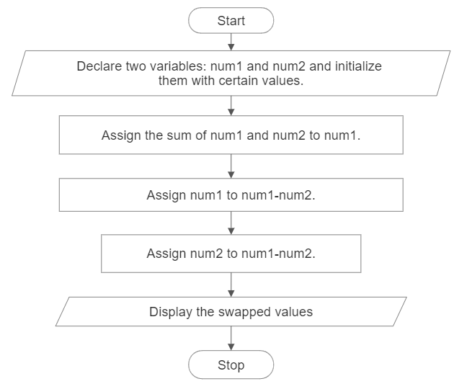Stop.

* **Flowchart**
* **Code**

#include <stdio.h>

int main()

{

int num1 = 10;

int num2 = 20;

printf("Before swapping:\n");

printf("num1 = %d\n", num1);

printf("num2 = %d\n", num2);

num1 = num1 + num2;

num2 = num1 - num2;

num1 = num1 - num2;

printf("After swapping (without using third variable):\n");

printf("num1 = %d\n", num1);

printf("num2 = %d\n", num2);

return 0;

}

* **Output**

Before swapping:

num1 = 10

num2 = 20

After swapping (without using third variable):

num1 = 20

num2 = 10

* **Discussion and Conclusion**

In the first part of the program, the values of num1 and num2 are swapped using a third variable. The values are stored in a temporary variable, temp, before swapping. Then, the values are exchanged by assigning num2 to num1 and temp to num2.

In the second part of the program, the values of num1 and num2 are swapped without using a third variable. This is achieved using the simple addition and subtraction operation. By performing that operations on the two variables, the original values are swapped without the need for an additional variable.

Both cases print the values of num1 and num2 before and after swapping to demonstrate the results. The program was implemented using the VS Code IDE and compiled using gcc to generate an executable file.

1. WAP to calculate the area and volume of a cylinder using pre-processor directive for value of PI.

* **Objective**

The objective of this program is to write a code that calculates the area and volume of a cylinder using a preprocessor directive for the value of pi.

* **Algorithm**

1. Start.
2. Define a preprocessor directive for the value of pi using #define.
3. Declare variables for the radius, height, area, and volume.
4. Assign predetermined values to the radius and height variables.
5. Calculate the area of the cylinder using the formula: area = 2 * PI * radius * (radius + height).
6. Calculate the volume of the cylinder using the formula: volume = PI * radius * radius * height.
7. Print the calculated area and volume.
8. Stop.

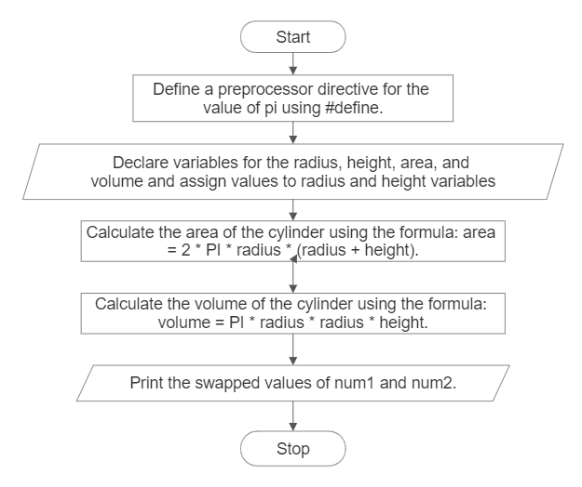

* **Flowchart**

Print the calculated area and volume.

* **Code**

#include <stdio.h>

#define PI 3.14159

int main()

{

float radius = 2.5;

float height = 5.0;

float area, volume;

area = 2 * PI * radius * (radius + height);

volume = PI * radius * radius * height;

printf("Area of the cylinder: %.2f\n", area);

printf("Volume of the cylinder: %.2f\n", volume);

return 0;

}

* **Output**

Area of the cylinder: 117.81

Volume of the cylinder: 98.17

* **Discussion and Conclusion**

This program calculates the area and volume of a cylinder using a preprocessor directive for the value of pi. The values of the radius and height are predetermined and assigned to the respective variables. The area of the cylinder is calculated using the formula: area = 2 * PI * radius * (radius + height), and the volume is calculated using the formula: volume = PI * radius * radius * height. The calculated values are then printed using the printf function. The program was implemented using the VS Code IDE and compiled using gcc to generate an executable file.

1. WAP to input two numbers from user and display the minimum using conditional operator.

* **Objective**

The objective of this program is to write a code that takes two numbers as input from the user and displays the minimum of the two numbers using the conditional operator.

* **Algorithm**

1. Start.
2. Declare variables num1, num2, and minimum.
3. Prompt the user to enter the first number and store it in num1.
4. Prompt the user to enter the second number and store it in num2.
5. Use the conditional operator to compare num1 and num2 and assign the smaller value to minimum.
6. Print the value of minimum.
7. Stop.

* **Flowchart**

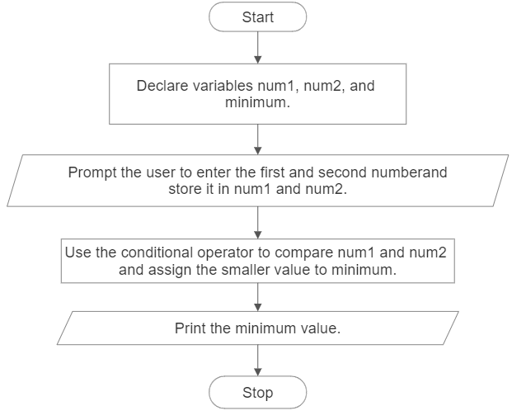

* **Code**

#include <stdio.h>

int main( )

{

int num1, num2, minimum;

printf("Enter the first number: ");

scanf("%d", &num1);

printf("Enter the second number: ");

scanf("%d", &num2);

minimum = (num1 < num2) ? num1 : num2;

printf("The minimum number is: %d\n", minimum);

return 0;

}

* **Output**

Enter the first number: 4

Enter the second number: 5

The minimum number is: 4

* **Discussion and Conclusion**

This program takes two numbers as input from the user and determines the minimum of the two numbers using the conditional operator. The user is prompted to enter the first number and the second number, which are stored in num1 and num2 variables, respectively. The conditional operator (num1 < num2) ? num1 : num2 compares the two numbers and assigns the smaller value to the minimum variable. Finally, the minimum value is printed using the printf function. The program was implemented using the VS Code IDE and compiled using gcc to generate an executable file.

1. WAP to display whether a number is even or odd using conditional operator

* **Objective**

The objective of this program is to write a code that takes a number as input from the user and displays whether the number is even or odd using the conditional operator.

* **Algorithm**

1. Start.
2. Declare a variable number to store the user input.
3. Prompt the user to enter a number and store it in the number variable.
4. Use the conditional operator to check if the number is even or odd.
5. If the number % 2 is equal to 0, assign the value "even" to a variable result, otherwise assign "odd".
6. Print the result indicating whether the number is even or odd.
7. Stop.

* **Flowchart**

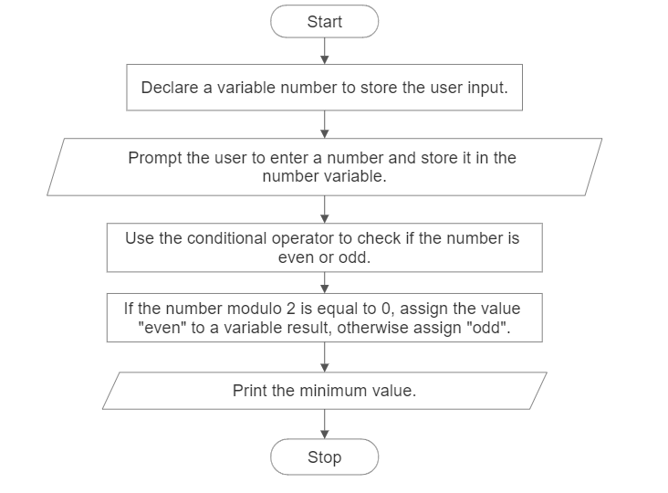

Print the result indicating whether the number is even or odd.

* **Code**

#include <stdio.h>

int main( )

{

    int number;

    char *result;

    printf("Enter a number: ");

    scanf("%d", &number);

    result = (number % 2 == 0) ? "even" : "odd";

    printf("The number is %s.\n", result);

    return 0;

}

* **Output**

Enter a number: 6

The number is even.

* **Discussion and Conclusion**

This program takes a number as input from the user and determines whether the number is even or odd using the conditional operator. The user is prompted to enter a number, which is stored in the number variable. The conditional operator (number % 2 == 0) ? "even" : "odd" checks if the number modulo 2 is equal to 0. If it is, the value "even" is assigned to the result variable; otherwise, the value "odd" is assigned. Finally, the program prints the result indicating whether the number is even or odd. The program was implemented using the VS Code IDE and compiled using gcc to generate an executable file.

1. What are the output of the following programs:

* **Objective**

The objective is to find the input of given code.

* **Code**

#include <stdio.h>

int main()

{

int a = 5, b = 9;

printf("a = %d, b = %d\n", a, b);

printf("a&b = %d\n", a & b);

printf("a|b = %d\n", a | b);

printf("a^b = %d\n", a ^ b);

printf("~a = %d\n", ~a);

printf("(b<<2)+(a<<1) = %d\n", (b << 2) + (a << 1));

printf("(b>>1)+(a>>1) = %d\n", (b >> 1) + (a >> 1));

return 0;

}

* **Output**

a = 5, b = 9

a&b = 1

a|b = 13

a^b = 12

~a = -6

(b<<2)+(a<<1) = 46

(b>>1)+(a>>1) = 6

* **Discussion and Conclusion**

The program displays the output showing the effects of the bitwise operations on the given variables.

* a & b performs a bitwise AND operation between a and b. In binary, 5 is 0101 and 9 is 1001. The result of a & b is 0001, which is equal to 1 in decimal.
* a | b performs a bitwise OR operation between a and b. In binary, the result is 1101, which is equal to 13 in decimal.
* a ^ b performs a bitwise XOR operation between a and b. In binary, the result is 1100, which is equal to 12 in decimal.
* ~a performs a bitwise complement operation on a. In binary, the result is 11111111111111111111111111111010, which is equal to -6 in decimal due to two's complement representation.
* (b<<2)+(a<<1) performs a left shift by 2 bits on b and a left shift by 1 bit on a, then adds the results. The value of b after the left shift is 36, and the value of a after the left shift is 10. The final result is 46.
* (b>>1)+(a>>1) performs a right shift by 1 bit on both b and a, then adds the results. The value of b after the right shift is 4, and the value of a after the right shift is 2. The final result is 7.

Lab Sheet 3

1. Write a C program to check whether a number is negative, positive, or zero.

* **Objective**

The objective of this program is to write a code that takes a number as input from the user and determines whether the number is negative, positive, or zero. The program will use conditional statements to check the value of the number and display the appropriate message indicating its classification.

* **Algorithm**

1. Start.
2. Declare a variable number to store the user input.
3. Prompt the user to enter a number and store it in the number variable.
4. Use conditional statements to check the value of the number:
5. If number is greater than 0, print "The number is positive."
6. If number is less than 0, print "The number is negative."
7. If number is equal to 0, print "The number is zero."
8. Stop.

* **Flowchart**

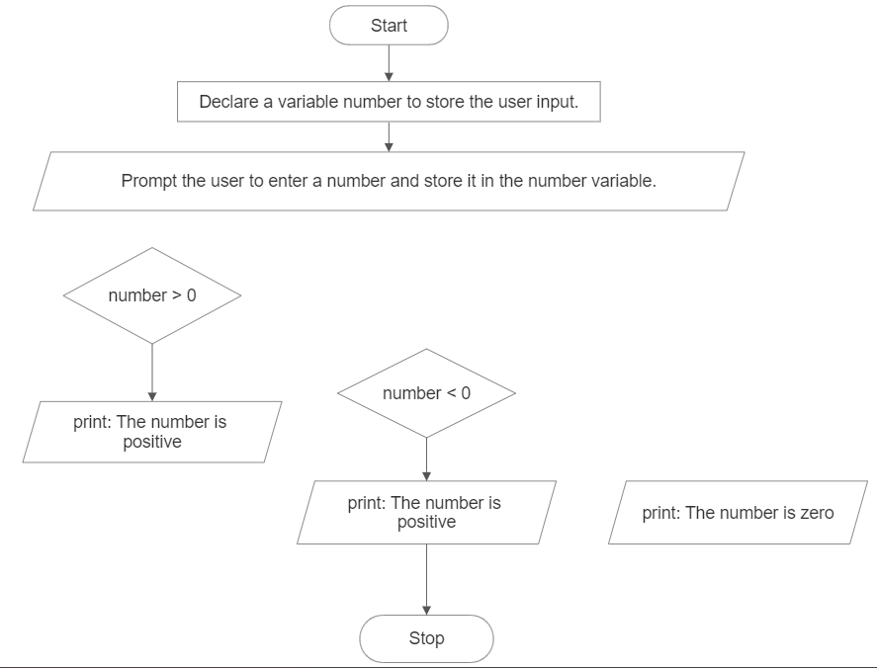

False

False

True

True

* **Code**

#include <stdio.h>

int main( )

{

int number;

printf("Enter a number: ");

scanf("%d", &number);

if (number > 0)

printf("The number is positive.\n");

else if (number < 0)

printf("The number is negative.\n");

else

printf("The number is zero.\n");

return 0;

}

* **Output**

Enter a number: 5

The number is positive.

* **Discussion and Conclusion**

This program takes a number as input from the user and determines whether the number is negative, positive, or zero using conditional statements. The user is prompted to enter a number, which is stored in the number variable. The program checks the value of the number using conditional statements (if, else if, and else) and prints the appropriate message indicating whether the number is positive, negative, or zero. The program was implemented using the VS Code IDE and compiled using GCC to generate an executable file. By using conditional statements, the program accurately classifies the input number based on its value.

1. WAP to find maximum between three numbers entered by the user.

* **Objective**

The objective of this program is to write a code that takes three numbers as input from the user and determines the maximum among them. The program will use conditional statements to compare the values of the three numbers and display the maximum value.

* **Algorithm**

1. Start.
2. Declare three variables num1, num2, and num3 to store the user input and another variable called max to store maximum number.
3. Prompt the user to enter three numbers and store them in the respective variables.
4. Use conditional statements to compare the values of the three numbers:

* If num1 is greater than both num2 and num3, it is the maximum.
* If num2 is greater than both num1 and num3, it is the maximum.
* If num3 is greater than both num1 and num2, it is the maximum.

1. Print the maximum value.
2. End the program.

* **Flowchart**

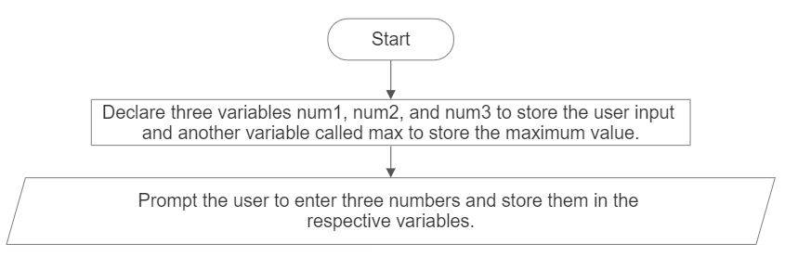

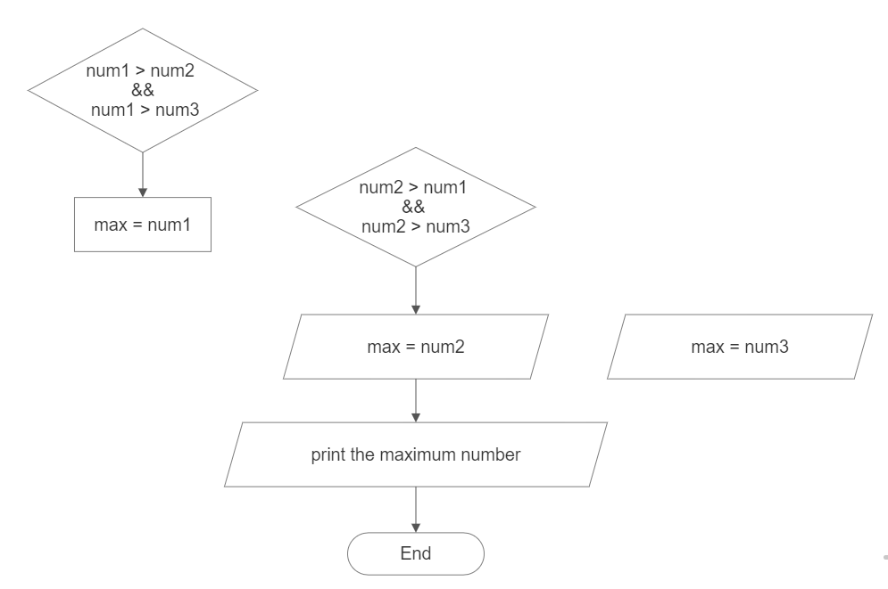

False

True

False

True

* **Code**

#include <stdio.h>

int main()

{

int num1, num2, num3, max;

printf("Enter three numbers: ");

scanf("%d %d %d", &num1, &num2, &num3);

if (num1 > num2 && num1 > num3)

max = num1;

else if (num2 > num1 && num2 > num3)

max = num2;

else

max = num3;

printf("The maximum number is: %d\n", max);

return 0;

}

* **Output**

Enter three numbers: 1 2 2

The maximum number is: 2

* **Discussion and Conclusion**

This program takes three numbers as input from the user and determines the maximum among them using conditional statements. The user is prompted to enter three numbers, which are stored in the variables num1, num2, and num3. The program compares the values of these numbers using conditional statements (if and else if) and assigns the maximum value to the variable max. Finally, the program prints the maximum number. The program was implemented using the VS Code IDE and compiled using GCC to generate an executable file. By comparing the values of the three numbers, the program accurately determines the maximum value.

1. WAP to input a character from the user and check whether the character is vowel or consonant.

* **Objective**

The objective of this program is to write a code that takes a character as input from the user and determines whether the character is a vowel or a consonant.

* **Algorithm**

1. Start.
2. Declare a variable ch to store the user input character.
3. Prompt the user to enter a character and store it in the ch variable.
4. Use conditional statements to check if the character is a vowel or a consonant:

* If ch is equal to 'a', 'e', 'i', 'o', or 'u', it is a vowel.

1. If the character is a vowel, print a message indicating that it is a vowel.
2. If the character is not a vowel, print a message indicating that it is a consonant.
3. Stop.

* **Flowchart**

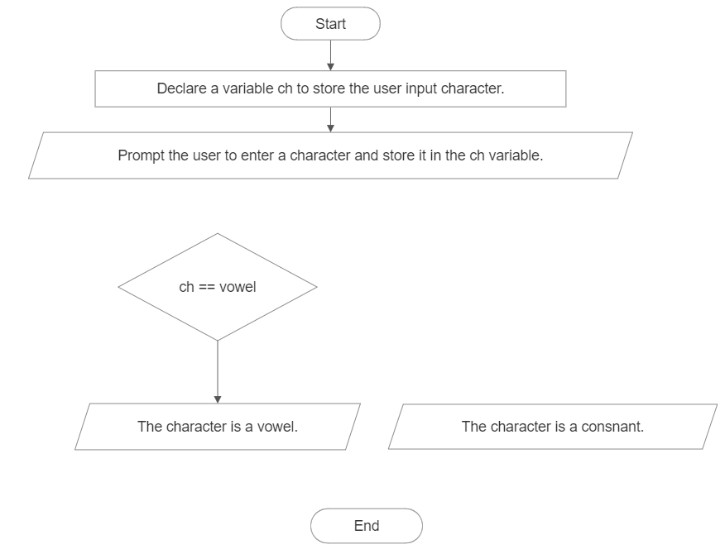

True

False

* **Code**

#include <stdio.h>

int main( )

{

char ch;

printf("Enter a character: ");

scanf(" %c", &ch);

if (ch == 'a' || ch == 'e' || ch == 'i' || ch == 'o' || ch == 'u' ||

ch == 'A' || ch == 'E' || ch == 'I' || ch == 'O' || ch == 'U')

{

printf("The character is a vowel.\n");

}

else

{

printf("The character is a consonant.\n");

}

return 0;

}

* **Output**

Enter a character: r

The character is a consonant.

* **Discussion**

This program takes a character as input from the user and checks whether the character is a vowel or a consonant using conditional statements. The user is prompted to enter a character, which is stored in the variable ch. The program compares the value of ch with the vowels ('a', 'e', 'i', 'o', 'u') in both lowercase and uppercase forms to determine whether it is a vowel. If it is a vowel, the program prints a message indicating that it is a vowel. If it is not a vowel, the program considers it a consonant and prints a corresponding message. The program was implemented using the VS Code IDE and compiled using GCC to generate an executable file. By comparing the value of the character with the predefined vowels, the program accurately determines whether it is a vowel or a consonant.

1. WAP to input a character from the user and check whether the character is Alphabet or not. If the character is alphabet then show whether it is uppercase or lowercase

* **Objective**

The objective of this program is to write a code that takes a character as input from the user and determines whether the character is an alphabet or not. If the character is an alphabet, the program will further identify whether it is in uppercase or lowercase.

* **Algorithm**

1. . Start.
2. Declare a variable ch to store the user input character.
3. Prompt the user to enter a character and store it in the ch variable.
4. Use conditional statements to check if the character is an alphabet:
5. If the ASCII value of ch is within the range of uppercase letters (65 to 90) or lowercase letters (97 to 122), it is an alphabet.
6. If the character is an alphabet, further check whether it is in uppercase or lowercase:
7. If the ASCII value of ch is within the range of uppercase letters (65 to 90), it is an uppercase letter and if the ASCII value of ch is within the range of lowercase letters (97 to 122), it is a lowercase letter.
8. Print the appropriate message indicating the result.
9. Stop.

* **Flowchart**

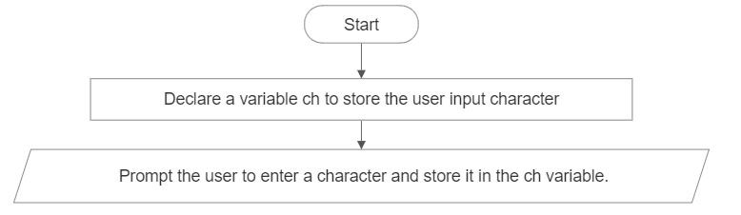

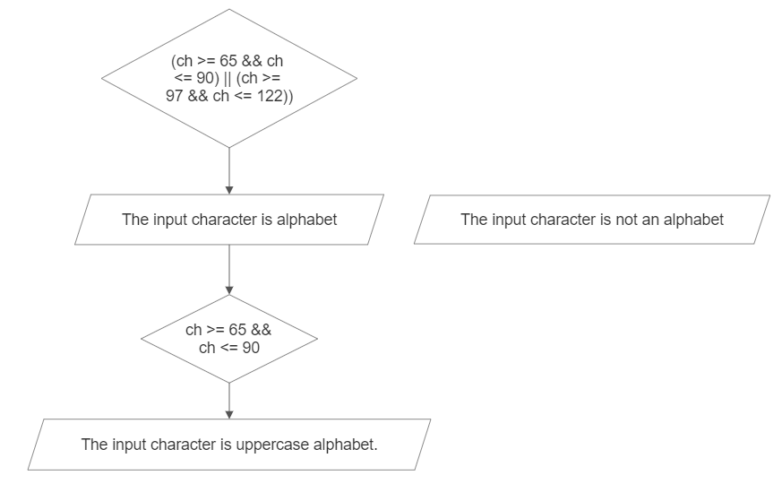

False

True

False

True

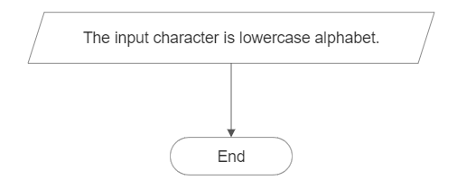

* **Code**

#include <stdio.h>

int main()

{

char ch;

printf("Enter a character: ");

scanf(" %c", &ch);

if ((ch >= 65 && ch <= 90) || (ch >= 97 && ch <= 122))

{

printf("The character is an alphabet.\n");

if (ch >= 65 && ch <= 90)

printf("It is in uppercase.\n");

else

printf("It is in lowercase.\n");

}

else

{

printf("The character is not an alphabet.\n");

}

return 0;

}

* **Output**

Enter a character: e

The character is an alphabet.

It is in lowercase.

* **Discussion and Conclusion**

This program takes a character as input from the user and checks whether the character is an alphabet or not using conditional statements. The user is prompted to enter a character, which is stored in the variable ch. The program compares the ASCII value of the character to determine if it falls within the range of uppercase or lowercase letters. If it is an alphabet, the program prints the appropriate messages indicating that it is an alphabet and whether it is in uppercase or lowercase. If it is not an alphabet, the program notifies the user accordingly. The program was implemented using the VS Code IDE and compiled using GCC to generate an executable file. By checking the ASCII value of the character, the program accurately determines whether it is an alphabet and its case.

1. WAP to check whether the year entered by the user is leap year or not

* **Objective**

The objective of this program is to write a code that takes a year as input from the user and determines whether the year is a leap year or not.

* **Algorithm**

1. . Start.
2. Declare a variable year to store the user input year.
3. Prompt the user to enter a year and store it in the year variable.
4. Use conditional statements to check if the year is a leap year:

* If the year is evenly divisible by 4, it is a potential leap year.
* If the year is also divisible by 100, it must be divisible by 400 to be considered a leap year.

1. If the year satisfies the leap year conditions, print a message indicating that it is a leap year.
2. If the year does not satisfy the leap year conditions, print a message indicating that it is not a leap year.
3. Stop.

* 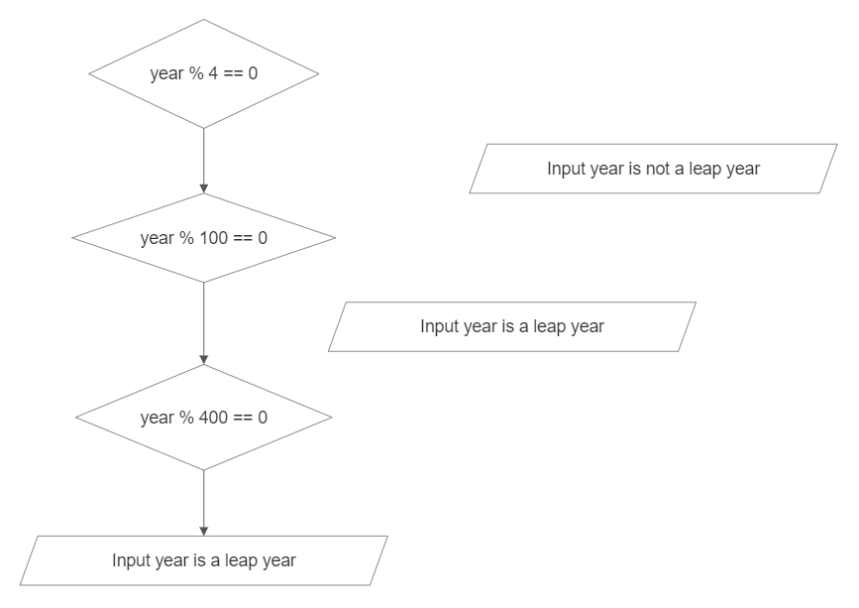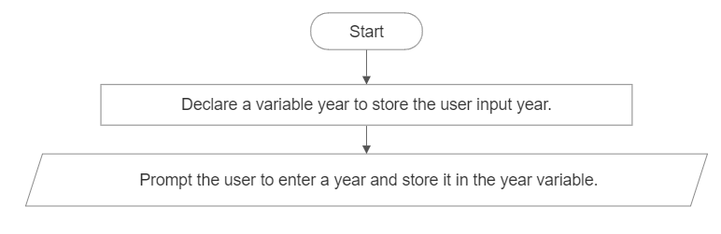**Flowchart**

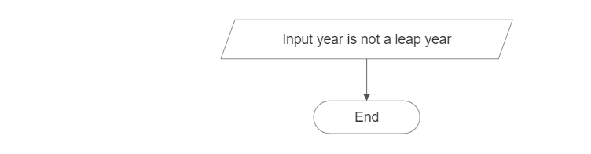

False

True

False

True

False

True

* **Code**

#include <stdio.h>

int main( ) {

    int year;

    printf("Enter a year: ");

    scanf("%d", &year);

    if (year % 4 == 0) {

        if (year % 100 == 0){

            if (year % 400 == 0){

                printf("%d is a leap year.\n", year);

            } else {

                printf("%d is not a leap year.\n", year);

            }

        } else {

            printf("%d is a leap year.\n", year);

        }

    } else {

        printf("%d is not a leap year.\n", year);

    }

    return 0;

}

* **Output**

Enter a year: 2022

2022 is not a leap year.

* **Discussion and Conclusion**

The program checks whether a year entered by the user is a leap year or not. It uses nested if statements to evaluate the leap year conditions. First, it checks if the year is divisible by 4. If it is, it further checks if the year is divisible by 100. If it is divisible by 100, it checks if it is also divisible by 400. If it satisfies all these conditions, it is considered a leap year. Otherwise, it is not a leap year. The program then displays the result accordingly. The program successfully determines whether a given year is a leap year or not using nested if statements. It prompts the user for a year and applies the leap year conditions to determine the result. The program was implemented using the VS Code IDE and compiled with GCC. By using the nested if statements, the program accurately identifies leap years based on the defined rules.

1. WAP to check whether the number entered by the user is divisible by 5 and 11 or not

* **Objective**

The objective of this program is to write a code that takes a number as input from the user and checks whether the number is divisible by both 5 and 11.

* **Algorithm**

1. Start.
2. Declare an integer variable number to store the user input.
3. Prompt the user to enter a number and store it in the number variable using scanf.
4. Use the modulo operator % to check if the number is divisible by 5 and 11.
5. If the remainder of the number divided by both 5 and 11 is 0, display a message indicating that the number is divisible by both 5 and 11.
6. If the condition in step v is not met, display a message indicating that the number is not divisible by both 5 and 11.
7. Stop.

* A picture containing text, screenshot, diagram, font

  Description automatically generated**Flowchart**

False

True

* **Code**

#include <stdio.h>

int main( ){

int number;

printf("Enter a number: ");

scanf("%d", &number);

if (number % 5 == 0 && number % 11 == 0) {

printf("%d is divisible by 5 and 11.\n", number);

} else {

printf("%d is not divisible by 5 and 11.\n", number);

}

return 0;

}

* **Output**

Enter a number: 55

55 is divisible by 5 and 11.

* **Discussion and Conclusion**

This program takes a number as input from the user and checks whether the number is divisible by both 5 and 11 using the modulo operator. If the remainder of the number divided by 5 and 11 is 0, it indicates that the number is divisible by both. Otherwise, it is not divisible by both. The program displays the appropriate message based on the divisibility result. The program provides the expected output.

1. WAP to find the all the roots of a quadratic equation.

* **Objective**

The objective of this program is to write a code that calculates and displays all the roots of a quadratic equation.

* **Algorithm**

1. Start.
2. Declare three variables a, b, and c to store the coefficients of the quadratic equation.
3. Prompt the user to enter the values of a, b, and c.
4. Calculate the discriminant using the formula discriminant = b * b - 4 * a * c.
5. Check the value of the discriminant:

If the discriminant is greater than 0, calculate the two roots using the formulas:

root1 = (-b + sqrt(discriminant)) / (2 * a)

root2 = (-b - sqrt(discriminant)) / (2 * a)

1. Display the roots.
2. If the discriminant is equal to 0, calculate the single root using the formula:
   * + root = -b / (2 * a)
3. Display the root.
4. If the discriminant is less than 0, calculate the complex roots using the formulas:

realPart = -b / (2 * a)

imaginaryPart = sqrt(-discriminant) / (2 * a)

1. Display the complex roots in the form of (realPart + imaginaryPart i) and (realPart - imaginaryPart.
2. 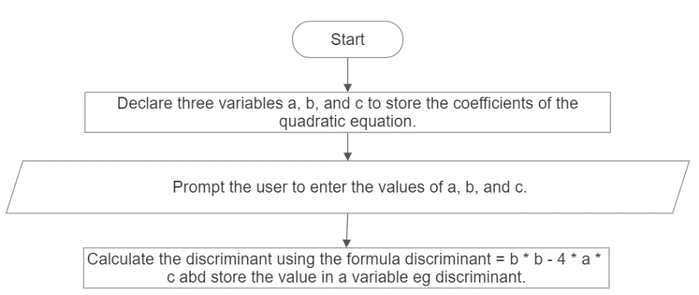Stop.

* **Flowchart**

False

False

True

True

* **Code**

#include <stdio.h>

#include <math.h>

int main( ) {

double a, b, c;

double discriminant, root1, root2, realPart, imaginaryPart;

printf("Enter the coefficients of the quadratic equation (a, b, c): ");

scanf("%lf %lf %lf", &a, &b, &c);

discriminant = b * b - 4 * a * c;

if (discriminant > 0) {

root1 = (-b + sqrt(discriminant)) / (2 * a);

root2 = (-b - sqrt(discriminant)) / (2 * a);

printf("Roots are real and different:\n");

printf("Root 1 = %.2lf\n", root1);

printf("Root 2 = %.2lf\n", root2);

} else if (discriminant == 0) {

root1 = -b / (2 * a);

printf("Roots are real and same:\n");

printf("Root = %.2lf\n", root1);

} else {

realPart = -b / (2 * a);

imaginaryPart = sqrt(-discriminant) / (2 * a);

printf("Roots are complex and different:\n");

printf("Root 1 = %.2lf + %.2lfi\n", realPart, imaginaryPart);

printf("Root 2 = %.2lf - %.2lfi\n", realPart, imaginaryPart);

}

return 0;

}

* **Output**

Enter the coefficients of the quadratic equation (a, b, c): 1 -3 10

Roots are complex and different:

Root 1 = 1.50 + 2.96i

Root 2 = 1.50 - 2.96i

* **Discussion and Conclusion**

This program calculates and displays all the roots of a quadratic equation, including real and complex roots. It calculates the discriminant and checks its value to determine the nature of the roots. If the discriminant is positive, it calculates and displays two distinct real roots. If the discriminant is zero, it calculates and displays a single real root. If the discriminant is negative, it calculates and displays two complex roots in the form of (realPart + imaginaryPart i) and (realPart - imaginaryPart i). The program provides the expected output for different input cases, including non-real roots.

1. WAP to input two numbers and operator among [ + , - ,* , / ]. If user enters + then the program should perform the addition of the number and display the sum. If user enters – then the program should perform subtraction of number and display the difference and so on for * and /.

* **Objective**

The objective of this program is to write a code that takes two numbers and an operator (+, -, *, /) as input from the user and performs the corresponding arithmetic operation, displaying the result.

* **Algorithm**
  1. Start.
  2. Declare three variables num1, num2, and result to store the two input numbers and the result of the arithmetic operation, respectively.
  3. Declare a variable operator to store the input operator.
  4. Prompt the user to enter the values of num1, num2, and operator.
  5. Use a switch statement to perform the arithmetic operation based on the input operator:
  6. If the operator is '+', add num1 and num2 and store the result in the result variable.
  7. If the operator is '-', subtract num2 from num1 and store the result in the result variable.
  8. If the operator is '*', multiply num1 and num2 and store the result in the result variable.
  9. If the operator is '/', divide num1 by num2 and store the result in the result variable.
  10. If none of the above cases match, display an error message.
  11. Display the result of the arithmetic operation.
  12. 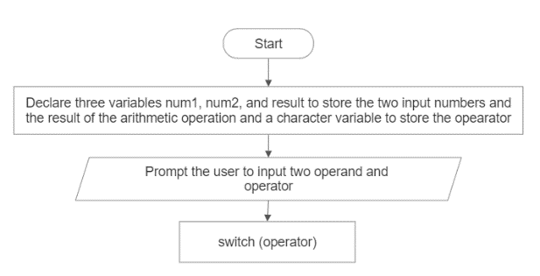Stop.
* A picture containing text, diagram, line, origami

  Description automatically generated**Flowchart**

True

True

True

True

False

False

False

False

* **Code**

#include <stdio.h>

int main( ){

double num1, num2, result;

char operator;

printf("Enter the first number: ");

scanf("%lf", &num1);

printf("Enter the second number: ");

scanf("%lf", &num2);

printf("Enter the operator (+, -, *, /): ");

scanf(" %c", &operator);

switch (operator) {

case '+':

result = num1 + num2;

printf("Result: %.2lf\n", result);

break;

case '-':

result = num1 - num2;

printf("Result: %.2lf\n", result);

break;

case '*':

result = num1 * num2;

printf("Result: %.2lf\n", result);

break;

case '/':

if (num2 != 0){

result = num1 / num2;

printf("Result: %.2lf\n", result);

} else{

printf("Error: Division by zero is not allowed.\n");

}

break;

default:

printf("Error: Invalid operator.\n");

}

return 0;

}

* **Output**

Enter the first number: 10

Enter the second number: 5

Enter the operator (+, -, *, /): +

Result: 15.00

* **Discussion and Conclusion**

This program allows the user to input two numbers and an operator (+, -, *, /). Based on the operator provided, the program performs the corresponding arithmetic operation and displays the result. It handles different scenarios such as addition, subtraction, multiplication, and division, while also checking for division by zero. The program provides the expected output for different input cases and ensures proper error handling. It was implemented using the VS Code IDE and compiled using GCC to generate an executable file.

1. WAP in C to input marks of five subjects C-programming, Physics, Maths, Applied Mechanics and Basic electrical. Display whether the student passed or failed. Take F.M=100 and P.M.=40 For passed students calculate percentage and grade according to following: Percentage >= 90% : A, Percentage >=80% : B , Percentage >= 70% : C , Percentage >= 60% : D , Percentage >= 40% : E

* **Objective**

The objective of this program is to write a code that takes marks of five subjects from the user and determines whether the student passed or failed. It also calculates the percentage and assigns a grade based on the given criteria.

* **Algorithm**

1. Start.
2. Declare variables to store the marks of each subject, the maximum marks (F.M.), the passing marks (P.M.), the total marks obtained, the percentage, and the grade.
3. Prompt the user to enter the marks of each subject (C-programming, Physics, Maths, Applied Mechanics, Basic Electrical) and store them in their respective variables.
4. Ensure the marks provided by student is <= 100 because FM= 100.
5. If the user has scored less than 40 in any of the subjects he failed.
6. If the user has not failed calculate his percentage as (total marks obtained / (F.M. * 5)) * 100 and assign him respective grades as Percentage >= 90%: Grade A Percentage >= 80%: Grade B Percentage >= 70%: Grade C Percentage >= 60%: Grade D Percentage >= 40%: Grade E
7. Display the result indicating whether the student passed or failed, the percentage obtained, and the grade assigned.
8. 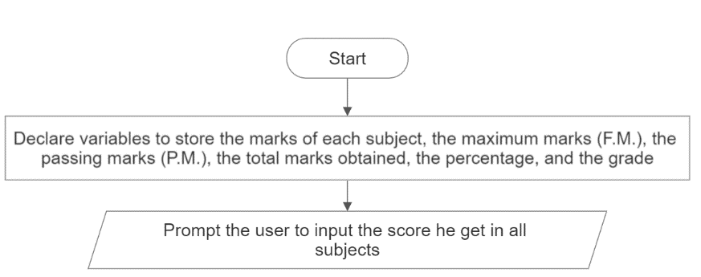Stop.

* **Flowchart**

**40**

**less**

less

False

False

False

False

False

False

False

True

True

True

True

True

True

True

* **Code**

#include <stdio.h>

int main( ) {

float cProgramming, physics, maths, appliedMechanics, basicElectrical, totalMarksObtained, percentage;

float FM = 100.0, PM = 40.0;

char grade;

printf("Enter marks for C Programming, Physics, Maths, Applied Mechanics, and Basic Electrical: ");

scanf("%f%f%f%f%f", &cProgramming, &physics, &maths, &appliedMechanics, &basicElectrical);

totalMarksObtained = cProgramming + physics + maths + appliedMechanics + basicElectrical;

if (cProgramming > FM || physics > FM || maths > FM || appliedMechanics > FM || basicElectrical > FM){

printf("Error: Marks cannot be greater than 100.\n");

} else if (cProgramming < PM || physics < PM || maths < PM || appliedMechanics < PM || basicElectrical < PM){

printf("Sorry, you have failed.\n");

} else {

percentage = (totalMarksObtained / (FM * 5.0)) * 100.0;

if (percentage >= 90.0){

grade = 'A';

}else if (percentage >= 80.0) {

grade = 'B';

}

else if (percentage >= 70.0) {

grade = 'C';

} else if (percentage >= 60.0) {

grade = 'D';

} else if (percentage >= 40.0) {

grade = 'E';

}

printf("Congratulations! You have passed.\n");

printf("Percentage: %.2f%%\n", percentage);

printf("Grade: %c\n", grade);

}

return 0;

}

* **Output**

Enter marks for C Programming, Physics, Maths, Applied Mechanics, and Basic Electrical: 85.5 78.2 92.6 81.8 73.4

Congratulations! You have passed.

Percentage: 82.70%

Grade: B

* **Discussion and Conclusion**

This program allows the user to input marks for five subjects (C Programming, Physics, Maths, Applied Mechanics, Basic Electrical) and determines whether the student passed or failed. It calculates the total marks obtained and checks if it is greater than or equal to the passing marks. If passed, it calculates the percentage and assigns a grade based on the given criteria. Finally, it displays the result indicating whether the student passed or failed, the percentage obtained, and the assigned grade. The program was implemented using the VS Code IDE and compiled using GCC to generate an executable file.

1. WAP to input a number from user. If user enters a number less than or equal to zero, then program should just display the number. If user enters 1 the program should display output as neither prime nor composite, if user enters 2 the program should display output as smallest and only even prime number. If user enters any number greater than 2 the program should check whether the number is prime or not, also if the number is not prime the program should display whether it is even or odd.

* **Objective**

The objective of this program is to take a number as input from the user and determine its properties. It checks if the number is less than or equal to zero and displays it as is. It also identifies if the number is 1, 2, or greater than 2, and performs specific checks accordingly. For numbers greater than 2, it determines whether the number is prime or composite and additionally checks if the number is even or odd.

* **Algorithm**

1. Start.
2. Declare the variables: number, and isPrime = 1.
3. Input a number from the user and store it in the number variable.
4. If number is less than or equal to zero, display the number.
5. If number is equal to 1, display "Neither prime nor composite".
6. If number is equal to 2, display "Smallest and only even prime number".
7. If number is greater than 2, check whether it is prime as follows:
8. Iterate from 2 to number / 2 using the variable i.
9. If number is divisible by i, set isPrime to 0 and break the loop.
10. If isPrime is 1, display "Number is prime" and stop.
11. If isPrime is 0, display "Number is not prime".
12. If number is even, display "Number is even".
13. If number is odd, display "Number is odd".
14. A picture containing text, font, screenshot, line

    Description automatically generatedStop.

* **Flowchart**

False

False

False

False

True

True

True

True

**Code**

False

False

False

True

True

True

#include <stdio.h>

int main( ) {

int number, isPrime = 1;

printf("Enter a number: ");

scanf("%d", &number);

if (number <= 0){

printf("Number: %d\n", number);

} else if (number == 1) {

printf("Neither prime nor composite\n");

} else if (number == 2) {

printf("Smallest and only even prime number\n");

} else {

for (int i = 2; i <= number / 2; i++) {

if (number % i == 0) {

isPrime = 0;

break;

}

}

  if (isPrime) {

printf("Number is prime\n");

} else{

printf("Number is not prime\n");

  if (number % 2 == 0){

printf("Number is even\n");

} else {

printf("Number is odd\n");

}

}

}

return 0;

}

* **Output**

Enter a number: 9

Number is not prime

Number is odd

* **Discussion and Conclusion**

This program accomplishes the objective of determining the properties of a given number. It correctly identifies numbers less than or equal to zero, 1, 2, and numbers greater than 2. It checks whether a number greater than 2 is prime or composite, and determines whether it is even or odd.

The program uses a combination of conditional statements and loops to implement the required logic. It takes user input, performs the necessary calculations, and displays the output accordingly. The code is written in the C programming language using standard input/output functions and basic arithmetic operations.

In conclusion, this program provides an effective solution to determine the properties of a given number. It showcases the use of conditional statements, loops, and arithmetic operations in C programming.

**Lab Sheet 4**

* + 1. WAP to get your name, address and display using unformatted I/O.
* **Objective**

The objective of this program is to input the name and address of the user and display them using unformatted I/O. Unformatted I/O allows reading and writing raw data without any specific formatting.

* **Algorithm**

1. Start.
2. Declare character arrays name and address to store the name and address, respectively.
3. Input the name of the user using unformatted input.
4. Input the address from the user using unformatted input.
5. Output the name and address using unformatted output.
6. Stop.

* A picture containing text, screenshot, font, diagram

  Description automatically generated**Flowchart**

Output

* **Code**

#include <stdio.h>

int main( ){

char name[100], address[100];

puts("Enter your name: ");

gets(name);

puts("Enter your address: ");

gets(address);

puts("\nYour details:\n");

puts("Name: ");

puts(name);

puts("Address: ");

puts(address);

return 0;

}

* **Output**

Enter your name: Tilak Thapa

Enter your address: Tulsipur – 4, Dang

Your details:

Name: Tilak Thapa

Address: Tulsipur – 4, Dang

* **Discussion and Conclusion**

This program allows the user to input their name and address using unformatted I/O, specifically the gets() function. Unformatted I/O allows reading and writing raw data without any specific formatting.

The program uses character arrays to store the name and address provided by the user. It prompts the user to enter their name and address, reads them using gets(), and then outputs the details using unformatted output with the puts() function. The code effectively demonstrates the use of unformatted I/O in C programming for reading and writing character data. It provides a simple and straightforward solution to input and display name and address using unformatted I/O.

In conclusion, this program successfully achieves its objective of obtaining and displaying the user's name and address using unformatted I/O. It showcases the usage of unformatted input and output functions in C programming.

* + 1. WAP to get a character form the user using unformatted I/O and display the ASCII value of the entered character.
* **Objective**

The objective of this program is to input a character from the user using unformatted I/O and display the ASCII value of the entered character.

* **Algorithm**

1. Start.
2. Declare a character variable ch to store the entered character.
3. Prompt the user to enter a character using unformatted input.
4. Read the character using unformatted input.
5. Display the ASCII value of the entered character.
6. Stop

* **Flowchart**
* 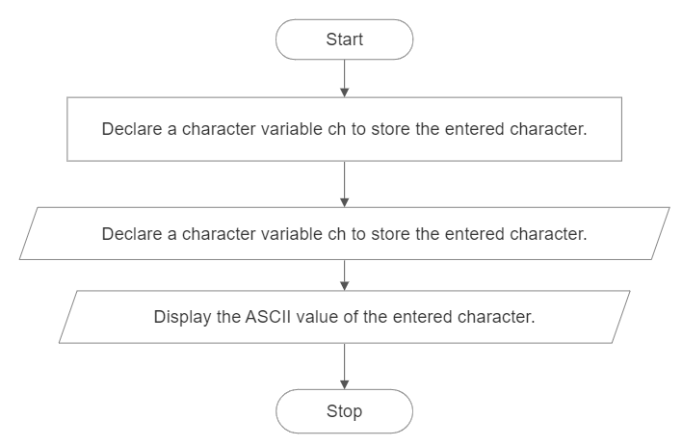**Code**

#include <stdio.h>

int main() {

char ch;

puts("Enter a character: ");

ch = getch();

puts("ASCII value of the entered character is: %d\n", ch);

return 0;

}

* **Output**

Enter a character: A

ASCII value of the entered character is: 65

* **Discussion and Conclusion**

This program uses unformatted I/O to input a character from the user and then displays the ASCII value of the entered character.

* + 1. WAP to display the output as [take a=15, b=20.43, c=35] as given.
* **Objective**

The objective of this program is to display the output as specified, with the given values of variables a, b, and c, using formatted I/O.

* **Algorithm**

1. Start.
2. Declare and initialize variables a, b, and c with the given values.
3. Use printf to display the output for variable A , B and C with the specified formatting.
4. Stop.

* **Flowchart**
* 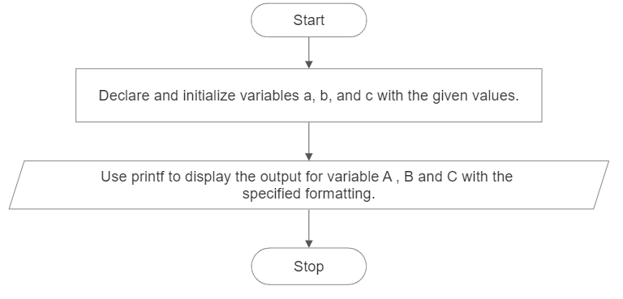**Code**

#include <stdio.h>

int main( )

{

int a = 15;

float b = 20.43;

int c = 35;

printf("A = %6d|%-6d|%6d|%-6d|%6d|%-6d|%6d|%-6d|%6d|%-6d|", a, a, a, a, a, a, a, a, a, a);

printf("\nB = %6.2f|%-6.2f|%6.2f|%-6.2f|%6.2f|%-6.2f|%6.2f|%-6.2f|%6.2f|%-6.2f|", b, b, b, b, b, b, b, b, b, b);

printf("\nC = %6d|%-6d|%6d|%-6d|%6d|%-6d|%6d|%-6d|%6d|%-6d|", c, c, c, c, c, c, c, c, c, c);

return 0;

}

* **Output**

A = 15|15 | 15|15 | 15|15 | 15|15 | 15|15 |

B = 20.43|20.43 | 20.43|20.43 | 20.43|20.43 | 20.43|20.43 | 20.43|20.43 |

C = 35|35 | 35|35 | 35|35 | 35|35 | 35|35 |

* **Discussion and Conclusion**

This program successfully displays the output as specified in the objective using formatted I/O with the specified formatting. It initializes the variables a, b, and c with the given values and then uses printf to display them in the desired format.The code uses format specifiers such as %d for integers (a and c) and %6d for right-aligned integers, %f for floating-point numbers (b) and %6.2f for right-aligned floating-point numbers with two decimal places. The - flag is used to left-align the values.

* + 1. WAP to display the output as below using formatted I/O [take char a[]=”I Love Nepal”].
* **Objective**

The objective of this program is to display the output as specified, which is a pyramid of characters obtained from the given string "I Love Nepal" using formatted I/O.

* **Algorithm**

1. Start
2. Declare and initialize a character array a with the given string "I Love Nepal".
3. Use printf with a specified width and precision to display the characters of the string incrementally, from the first character to the current character.
4. Stop.

* **Flowchart**

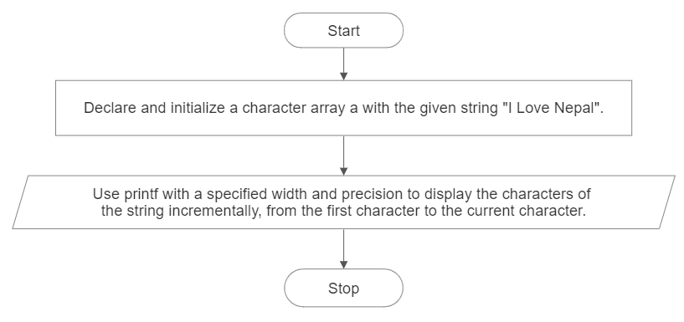

* **Code**

#include <stdio.h>

int main( ) {

char a[] = "I Love Nepal";

printf("%1.1s\n", a);

printf("%1.3s\n", a);

printf("%1.4s\n", a);

printf("%1.5s\n", a);

printf("%1.7s\n", a);

printf("%1.8s\n", a);

printf("%1.9s\n", a);

printf("%1.10s\n", a);

printf("%1.11s\n", a);

printf("%1.12s\n", a);

return 0;

}

* **Output**

I

I L

I Lo

I Lov

I Love

I Love N

I Love Ne

I Love Nep

I Love Nepa

I Love Nepal

* **Discussion and Conclusion**

This program successfully displays the desired output using formatted I/O. It initializes a character array a with the given string "I Love Nepal" and then uses printf with a specified width and precision to display the characters incrementally and create a pyramid pattern.

By specifying the width and precision in the format string of printf, we can control the number of characters to be displayed. The width represents the minimum field width, and the precision represents the maximum number of characters to be displayed.